Cell Phone Detector

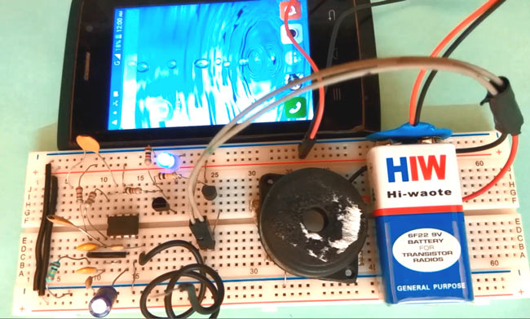**INDEX**

|  |  |  |
| --- | --- | --- |
| S.NO | CONTENTS | PAGE NO |
| 1. | Abstract |  |
| 2. | Introduction |  |
| 3. | Circuit diagram |  |
| 4. | Components |  |
| 5. | Procedure |  |
| 6. | Conclusion |  |
|  |  |  |
|  |  |  |

Abstract

**Aim of the project**:

The aim of the project is to detect the cell phone using OP-amp

**Importance and use**:

The circuit is intended to detect unauthorized use of mobile phones in examination halls, confidential rooms etc. It also helps to detect unauthorized video and audio recordings. It detects the signal from mobile phones even if it is kept in the silent mode.

**Advantages:**

->easy to use

->low cost

->smaller in size

->less power supply

->thermal stability

->long life

**Future enhancements:**

Trying to increase the detection range of cell phone detector to few more meters for observing wide range of area.

Introduction

In this modern world, the technology increases day by day electronic components with wide range of features and becoming minute in size. As the usage o increases, there is a misuse of electronic components by using them in confidential rooms and some restricted areas. To get rid of these situations , cell phone detector is the equipment used to detect .This transmission detector detects the presence of activated mobile cell phone. Inorder to prevent the electronic gadgets to confidential places ,official meetings etc .this mobile detector circuit detect incoming/outgoing calls, messaging ,video transmission and any SMS or GPRS uses within the range of 1 meter.

Circuit diagram



Components required

* Op-Amp CA3130
* 2.2M resistor (2)

100K resistor (1)

1K resistor (3)

* 100nF capacitor (4)

22pF capacitor (2)

100uF capacitor   (1)

47pF capacitor        (2)

* Bread board
* 9 Volt Battery
* Battery Connector
* LED
* Transistor BC548
* Connecting wires
* Buzzer
* Antenna

Op-Amp CA3130:

**CA3130** are **op amps** that combine the advantage of both CMOS and bipolar transistors. Gate-protected P-Channel MOSFET (PMOS) transistors are used in the input circuit to provide very-high-input impedance, very-low-input current, and exceptional speed performance

.

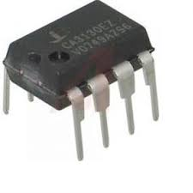

Transistor-BC548 The **BC548** is a general-purpose NPN bipolar junction **transistor** commonly used in European and American electronic equipment. It is notably often the first type of bipolar **transistor** hobbyists encounter and is often featured in designs in hobby electronics magazines where a general-purpose **transistor** is required.

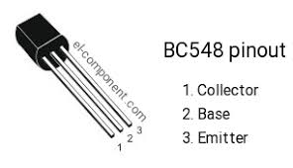

Antenna

An antenna is the interface between radio waves propagating through space and electric currents moving in metal conductors, used with a transmitter or receiver.

IC 555 Timer

The 555 timer IC is an integrated circuit used in a variety of timer, pulse generation, and oscillator applications. The 555 can be used to provide time delays, as an oscillator, and as a flip-flop element. Derivatives provide two or four timing circuits in one package.

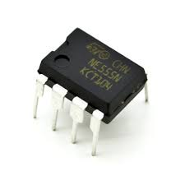

Buzzer

A buzzer or beeper is an [audio](https://en.wikipedia.org/wiki/Sound) signaling device, which may be mechanical, electromechanical, or piezo electric . Typical uses of buzzers and beepers includes alarm involved devices, timers, and confirmation of user input such as a mouse click or keystroke

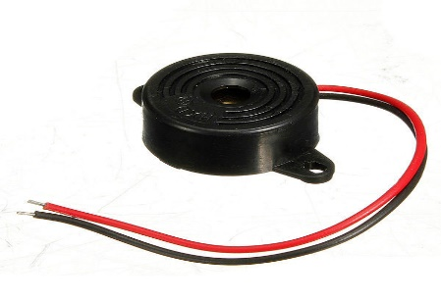

.

Procedure

In this circuit ,CA3130 OP-AMP IC is used for detecting incoming or outgoing signal around it .OP-amp non inverting end is connected to vcc through 2.2M resistor and it is also connected to the ground through 100K resistor and 100uF Capacitor. Its inverting terminal is feedback from its output through a 2.2M resistor for amplify the signal. Two 100nF capacitors are connected between inverting and non-inverting terminal, working as loop antenna for the system. Two 100nF capacitors are connected in series between Pin 1 and 8 of op-amp to boost the gain of the current to voltage converter at its output pin.

Output of this op-amp is connected at the base of NPN transistor namely BC547 through a 1k resistor and a LED is connected at its emitter for indication. A buzzer is also used for sound indication by using a PNP transistor namely BC557. And a 9 volt battery is used for powering the circuit. Rests of connections are shown in the Circuit Diagram below.

Conclusion

This pocket-size mobile transmission detector or sniffer can sense the presence of an activated mobile cell phone from a distance of one meter. so it can be used to prevent use of mobile phone for spying and unauthorized video transmission.